Source Data Mapping Approach to CDMV6.0

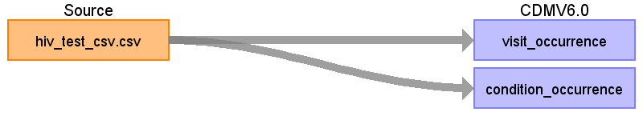

Table name: visit_occurrence

Reading from hiv_test_csv.csv

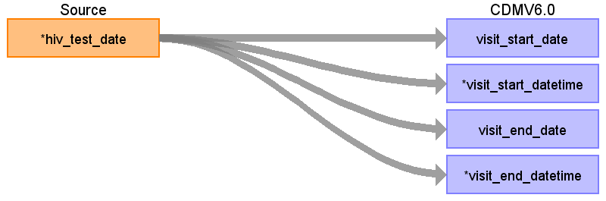

|  |  |  |  |
| --- | --- | --- | --- |
| Destination Field | Source Field | Logic | Comment |
| visit_occurrence_id |  |  |  |
| person_id |  |  |  |
| visit_concept_id |  |  |  |
| visit_start_date | hiv_test_date |  |  |
| visit_start_datetime | hiv_test_date |  |  |
| visit_end_date | hiv_test_date |  |  |
| visit_end_datetime | hiv_test_date |  |  |
| visit_type_concept_id |  |  |  |
| provider_id |  |  |  |
| care_site_id |  |  |  |
| visit_source_value |  |  |  |
| visit_source_concept_id |  |  |  |
| admitting_source_concept_id |  |  |  |
| admitting_source_value |  |  |  |
| discharge_to_concept_id |  |  |  |
| discharge_to_source_value |  |  |  |
| preceding_visit_occurrence_id |  |  |  |

Table name: condition_occurrence

Reading from hiv_test_csv.csv

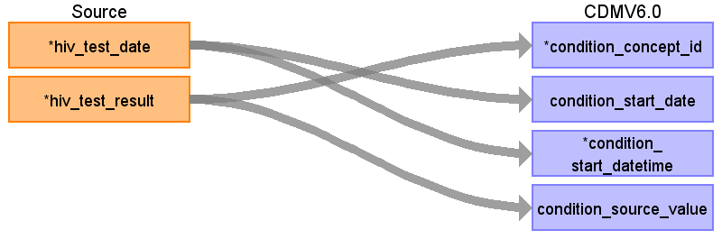

|  |  |  |  |
| --- | --- | --- | --- |
| Destination Field | Source Field | Logic | Comment |
| condition_occurrence_id |  |  |  |
| person_id |  |  |  |
| condition_concept_id | hiv_test_result |  |  |
| condition_start_date | hiv_test_date |  |  |
| condition_start_datetime | hiv_test_date |  |  |
| condition_end_date |  |  |  |
| condition_end_datetime |  |  |  |
| condition_type_concept_id |  |  |  |
| condition_status_concept_id |  |  |  |
| stop_reason |  |  |  |
| provider_id |  |  |  |
| visit_occurrence_id |  |  |  |
| visit_detail_id |  |  |  |
| condition_source_value | hiv_test_result |  |  |
| condition_source_concept_id |  |  |  |
| condition_status_source_value |  |  |  |